Printing the Purchase Order
__________________________________________

_____1. Retrieving a purchase order for the initial print. From Reports > Purchase Order Reports > REQ1450 Print Purchase Orders, enter the desired parameters. All parameters that are bolded must contain a value. Non-bolded parameters are optional. The parameters shown below will print all current approved Purchase Orders that have not been printed previously. Once the parameters are entered, select Run Preview.

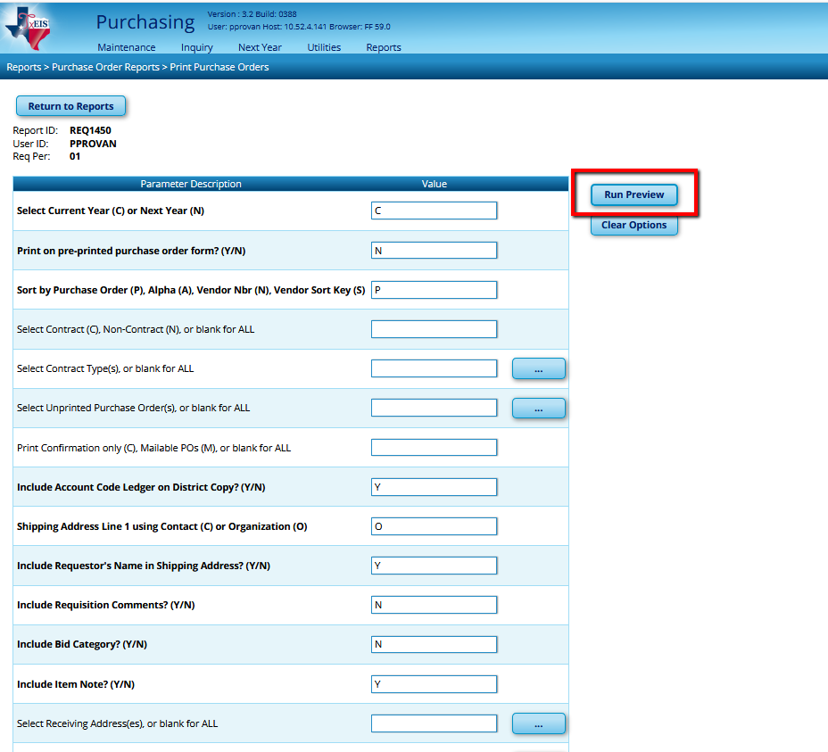
Specific PO’s may be selected by clicking the box to the right.

(Additional parameters on next page…)

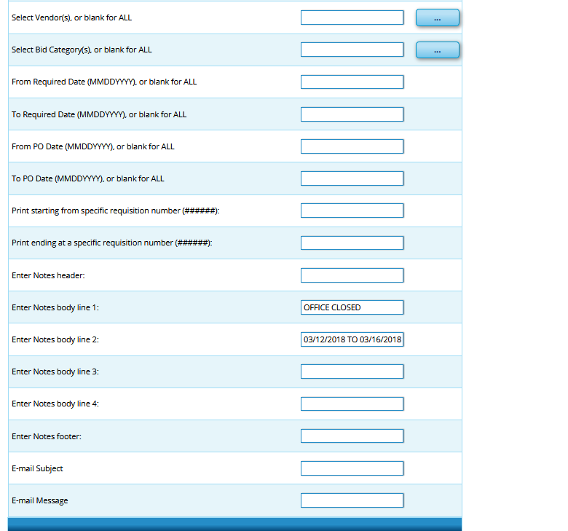
Additional Notes can be added here. The Notes will print on all PO’s selected in your parameters.

_____2. Viewing the vendor copy. The Vendor Copy of the PO will appear on your screen.

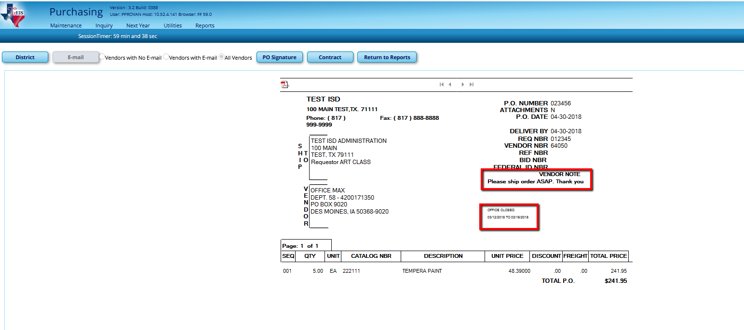

If Vendor Notes were added to the requisition, they will appear at the top, under Federal ID NBR.

If Notes were added on the report parameters screen, they will print below the Vendor Note on all PO’s selected.

_____3. Viewing the district copy. For the District view, select the District button in the upper left corner. The District PO displays the same information but adds account codes.

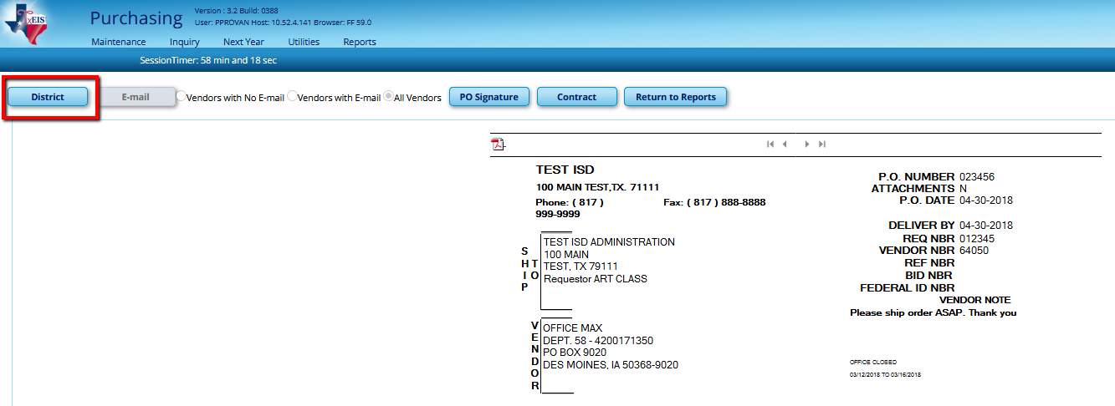

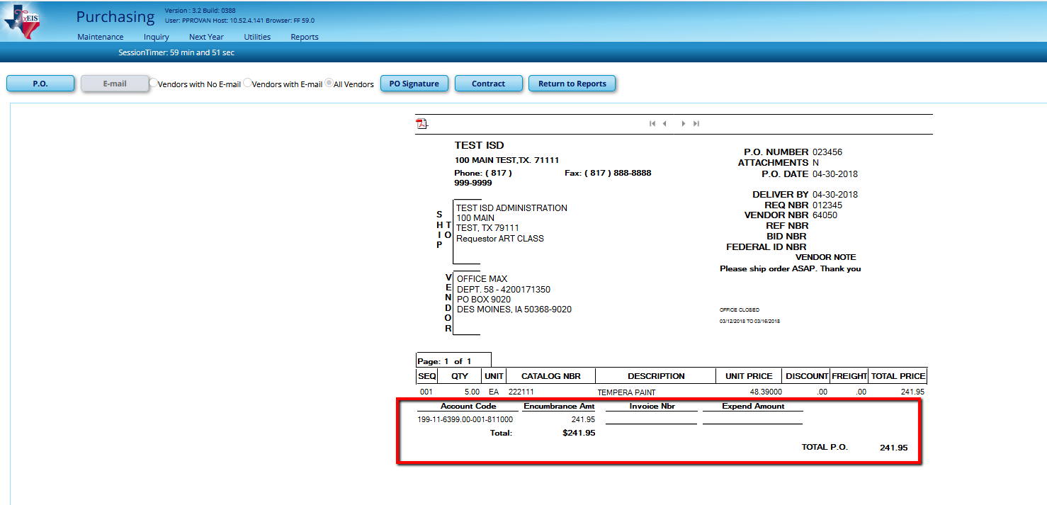

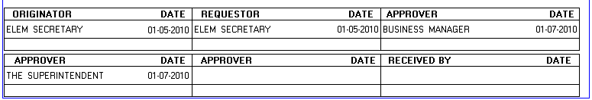

If you want to see the Vendor view again click the PO button in the top left-hand corner.
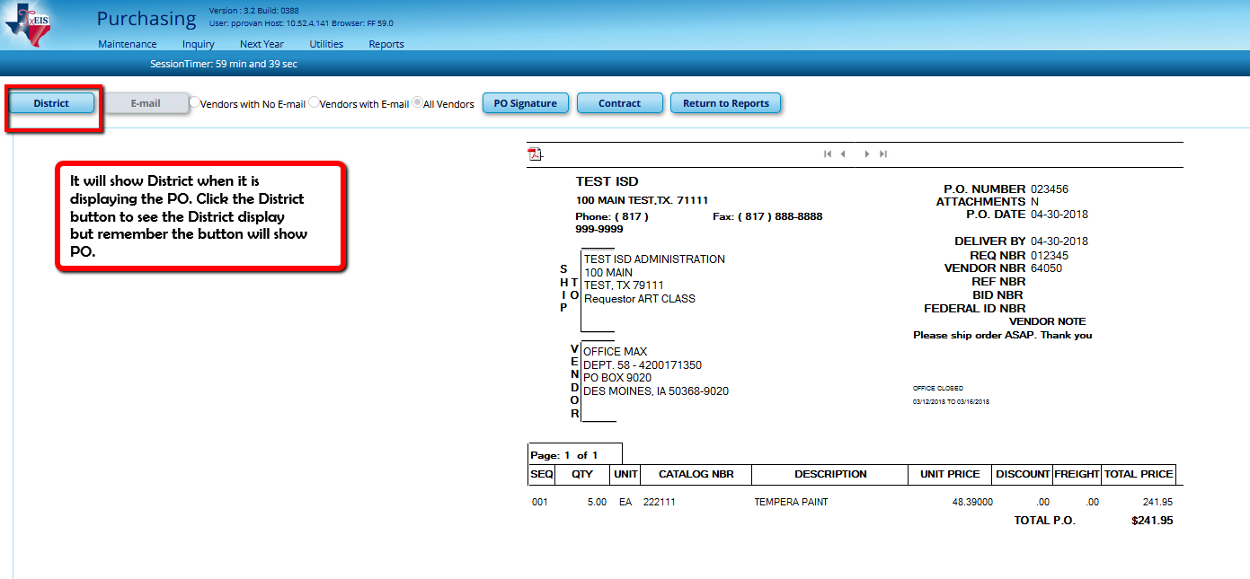

_____4. Signing the purchase order. An encrypted signature can be added to the PO if desired. The PO Signature button activates this feature and will print in the last available Approver box at the bottom of the PO. Contact Region 14 TxEIS Business Consultants for assistance with signatures.

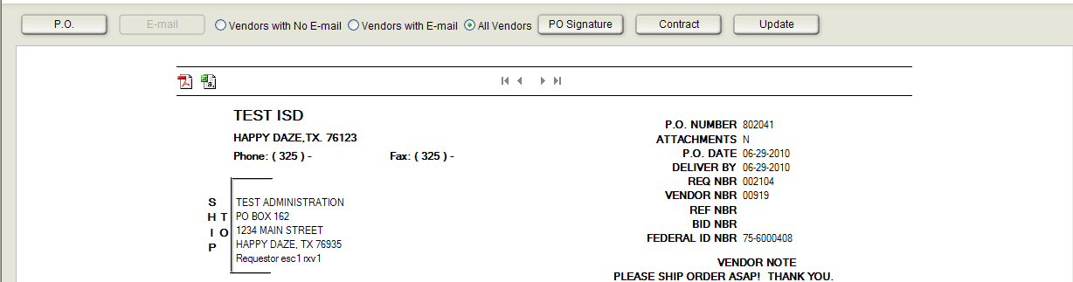

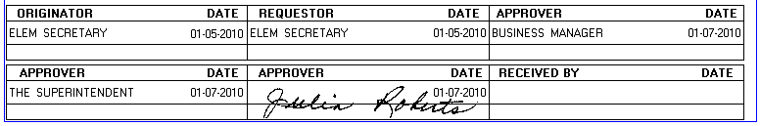

_____5. E-mailing the purchase order. PO’s may be emailed if there is an email address in the Vendor’s information in Finance. Radio buttons allow you to see PO’s of Vendors with no email addresses, with addresses or all Vendors with a PO, whether or not they have email addresses. To email, select the Vendors with Email button. Only PO’s of Vendors with an email address will appear. Select Email. The Email button turns into a “Stop Email” button so you can stop the process if needed. Vendors will receive an email with the PO attached in pdf format. Selecting the Vendors with No Email radio button will display the remaining PO’s that need to be printed.

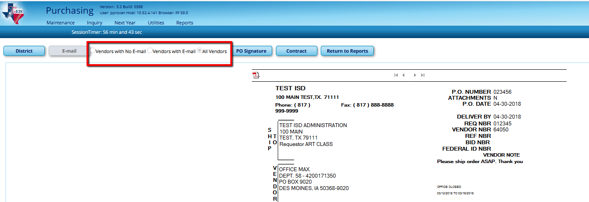

_____6. Printing the purchase order. To Print, select the PDF icon in the view (Vendor or District) desired. Print as you do any report, sending to the printer of your choice.

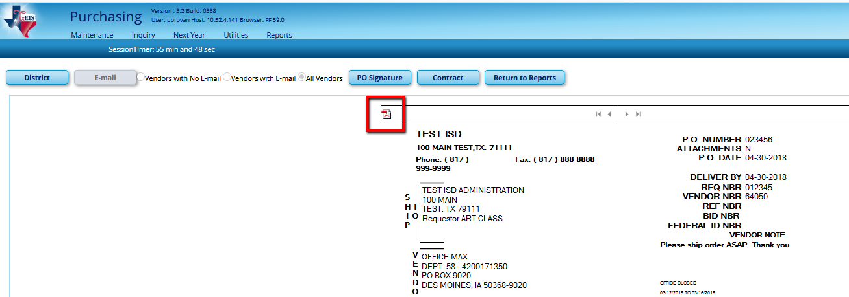

Once you print the PO, it will no longer be available in this Reports > Purchase Order Reports > REQ1450 Print Purchase Orders report area. If you need another copy, it will only be available in Reports > Purchase Order Reports > REQ1500 Reprint Purchase Orders. The process is the same as printing the original.

